**GASABO DISTRICT**

**ACADEMIC YEAR 2022 - 2023**

**EXAM TITLE: SETUP LAN**

**RTQF LEVEL: LEVEL IV**

**OPTION: NETWORKING**

**DURATION: 3HOURS**

**INSTRUCTION TO CANDIDATES:**

This paper consists of two sections, A and B

Section A: Attempt all questions 55 marks

Section B: Attempt three (3) questions of your choice: 45 marks

**Duration:** 3hours

SECTION ONE: ATTEMPT ALL QUESTIONS OF THIS SECTION [55 MARKS]

1. Select the best answer for the following questions **[2 Marks for each question]**
2. What does protocol defines?
3. Protocol defines what data is communicated.
4. Protocol defines how data is communicated.
5. Protocol defines when data is communicated.
6. All of above
7. Full Form of NIC?
   * 1. New Internet Connection
     2. Network Interface Card
     3. Network Interface Connection
     4. Net Interface Card
8. Which of the following is true example of Mac address:
9. 18:3D:A2:83:B5:1F
10. 00:3G:F2:83:9C:67
11. 18:3D:A2:8F:B5:AO
12. N8:3D:E0:83:B5:1F
13. Router operates in which layer of OSI Reference Model?
14. Layer 1 (Physical Layer)
15. Layer 3 (Network Layer)
16. Layer4 (Transport Layer)
17. Layer 7 (Application Layer)
18. You need to troubleshoot your network IP connectivity. Which of the following commands would you use to find the IP address on your Ethernet 0 interface?
19. ping
20. IPConfig
21. traceroute
22. Show interface Ethernet 0
23. Which of the following prompts indicates your router is in Privileged EXEC mode?
24. Router>
25. Router#
26. Router&
27. Router$
28. You are configuring your Cisco router and need to go back to User EXEC mode. What command will take you back to User EXEC mode?
29. Router1#enable
30. Router1#exit
31. Router1#configure terminal
32. Router1#disable
33. What is the uses of subnetting?
34. It divides one large network into several smaller ones
35. It divides network into network classes
36. It speeds up the speed of network
37. None of above
38. Which one of the following protocol is not used in internet?
39. HTTP
40. DHCP
41. DNS
42. None of the mentioned
43. 18.13.241.8 address lies in which class
    * 1. class A
      2. class B
      3. class D
      4. class E
44. . IPV4 Address is
45. . 8 bit
46. 16 bit
47. 32 bit
48. 64 bit
49. Star topology is based on a central device that can be……………?
50. Hub
51. Switch
52. Only i
53. Both i and ii

|  |  |
| --- | --- |
|  |  |
|  |  |
|  |  |

1. How much wire does a twisted pair cable have?
   * 1. 1
     2. 2
     3. 4
     4. 8
2. Name the parts of the network below accordingly**: [7marks]**

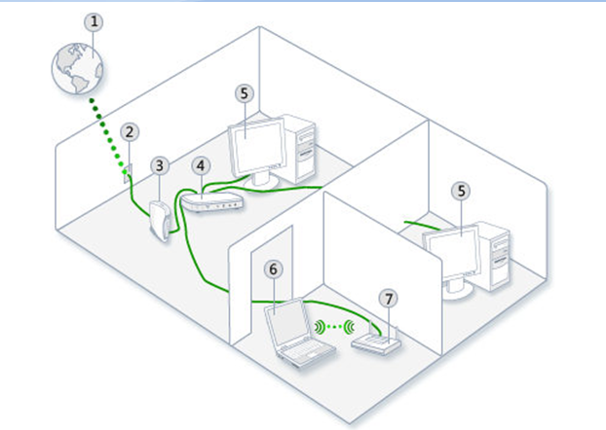

1. What are the purpose of having a network, especially LAN **[4marks]**
2. Match the column A with their corresponding in Column B: **[8marks]**

|  |  |  |
| --- | --- | --- |
| **Column A** | **Column B** | **answer** |
| 1. Packet tracer | A. Refers to layout of a network: how different nodes in a network are connected to each other and how they communicate. |  |
| 2. LAN ports | B. is a type of connector commonly used for [Ethernet](https://techterms.com/definition/ethernet) networking |  |
| 3. RJ45 | C. is a high-speed device that receives incoming data packets and redirects them to their destination on a LAN |  |
| 4. NIC | D. Tool utilized in training for Network certifications by allowing students to create networks with an almost unlimited number of devices and to experience troubleshooting without having to buy real Cisco routers or switches. |  |
| 5. Wireless access point | E. A common network communication standard, which is used to define a method of exchanging data over a computer network. |  |
| 6. A switch | F.Is a device that performs the functions of a router and also includes the functions of a wireless access point. It is used to provide access to the Internet or a private computer network. |  |
| 7. A network protocol | G. It is a [computer hardware](https://en.wikipedia.org/wiki/Computer_hardware) component that connects a [computer](https://en.wikipedia.org/wiki/Computer) to a [computer network](https://en.wikipedia.org/wiki/Computer_network). |  |
| 8*.* Network Topology | H. Ports where you connect network devices such as client machines, server and other network devices |  |

1. List different methods you may use to access router **[3marks]**
2. What is MAC address? How does it differ from an IP address? **[4marks]**
3. Refer to the exhibit. Which three labels correctly identify the network types for the network segments that are shown? (Choose three) **[3marks]**

a) Network A — WAN

b) Network B — WAN

c) Network C — LAN

d) Network B — MAN

e) Network C — WAN

f) Network A – LAN



SECTION TWO: Attempt Three (3) questions of your choice: [15 marks for each question]

1. List and explain all steps required to identify network problems? **[15marks]**
2. State and explain all network troubleshooting tools you know **[15marks]**

.

1. List and explain IOS Configuration mode **[15marks]**
2. Design a LAN that can allow six wired computers and two wireless devices to share the internet **[15marks]**

**Answer:**

1. Enumerate all tools and steps required to make Ethernet cable. **[15marks]**

**GOOD LUCK**